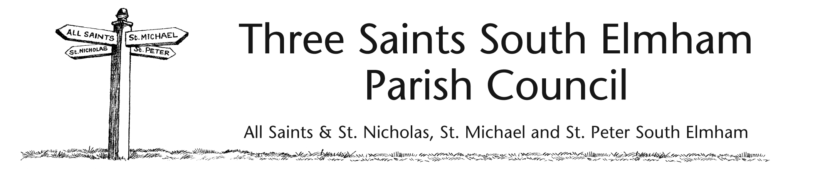

MEETING – 21ST JANUARY 2014

DRAFT MINUTES

1. The chairman, John Davies, welcomed councillors Louise Rumball, David Lee, Paul Watkin, Daniel Brousson; Kim Croysdill was absent. The clerk, Caroline Cardwell, was in attendance.
2. Declarations of interest – none
3. Have Your Say [Public Forum] – no members of the public present.
4. Clerk, new – the appointment of Caroline Cardwell was approved, the salary discussed and a NALC contract signed – the chairman welcomed her to the council.
5. Minutes of previous meeting [11-11-13] were approved and signed as a true record.
6. Matters arising [report on previous minutes] – none
7. Finances – balances at 27-12-13 – c/acct: £2,381.41; sav acct £1,393.50; cheques approved as follows –no. 100572 to C. Cardwell for £87.67p [net salary for Jan]; no.100573 to Rumburgh Youth Club for £50.00 [Xmas party]. Councillors agreed to ask Heelis and Lodge to carry out the internal audit for the year ending Mar.2014.
8. All Saints common – encroachment on the common was extensively discussed. Further research needs to be done on Haylocks Cottage garden and previous communications with the owner. The clerk to again contact The Land Registry when further information from archives has been checked.
9. St. Peter’s bench – lettering for back chosen; John Davies to contact Jason Parr.
10. Correspondence – none
11. Any other business – asbestos dumped at St. Peter – John Davies to contact WDC to clear. There were concerns over flooding on the St. James road by All Saints bus shelter – clerk to contact SCC Highways. The PC AGM and the village Parish Meeting were arranged for 28th May 2014. The clerk raised the question of the risk assessment of parish assets and will circulate information to councillors so it can be carried out before the next meeting.
12. Next meeting - 18th March 2014 – 8pm.